.......................................................... AIR EXTREME PARTY
NAME: ……............................……............................……............................…………...
TIME: ……............................……............................……............................……............
DATE: ……............................……............................……...................................……...
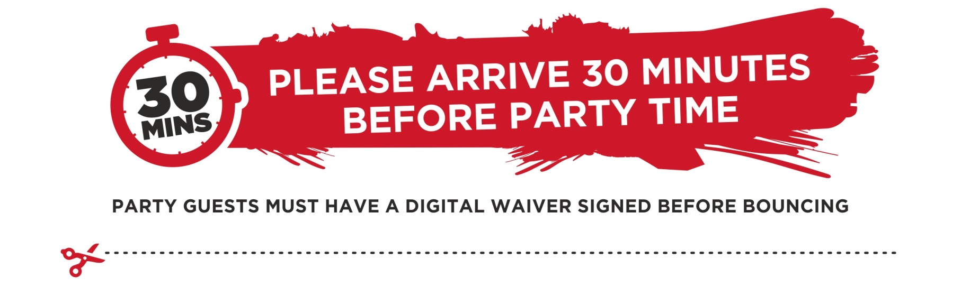Please cut out this part to let me know you can make it to my party!
I, …………..................................... will be there at Air Extreme for .....................................party.
I already have a waiver My parent will sign a waiver for me online before the party
PLEASE SIGN WAVIER VIA OUR WEBSITE

